Test Plan for E-Commerce Web App

Prepared for: Open Classrooms

Prepared by: Steve Cunningham

Classic Vintage Cameras

November 21 2021

# Overview

## Introduction

This plan describes the testing approach that will serve as the fundamental strategy for our Classic Vintage Cameras E-Commerce Web App. The purpose of the app is to provide the user with a single list of items that they can manage with simple actions. It will be built only for web use.

The product requirements for the Classic Vintage Cameras are as follows:

A user can view list of items

A user can choose from a choice of lenses from the list

A user can add an item to the basket.

A user can delete an item from the list.

## Features to Test

1. A user can view list of products when opening home page

* + - 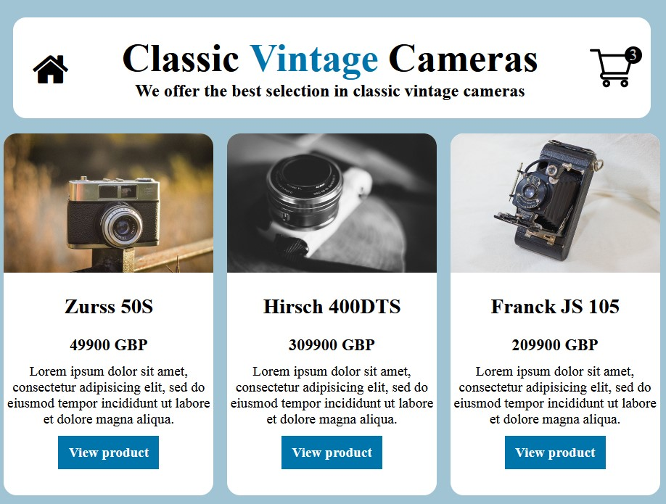User can click “view product” button to move to single item page

2. A user can add items to cart from Single Page

* + - User can click on add to cart button to add items they wish to purchase
    - User can choose from selection of Camera Lenses from drop down menu

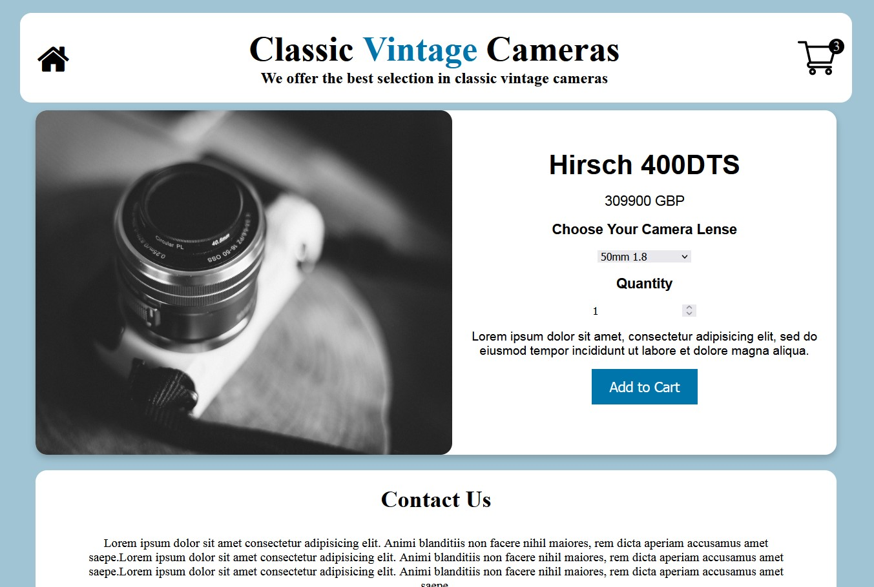

3. A user can delete or add an item from list on Cart Page

* + - User can view list of items wishing to purchase on cart page
    - User can update quantity or remove items from list in Cart Page
    - Existing item is removed from the page after deleting item
    - User can click on the “empty cart” button to remove all cart items at once
    - User can fill order form details to submit the order
    - User to be redirected to Order Received page after submitting the order form

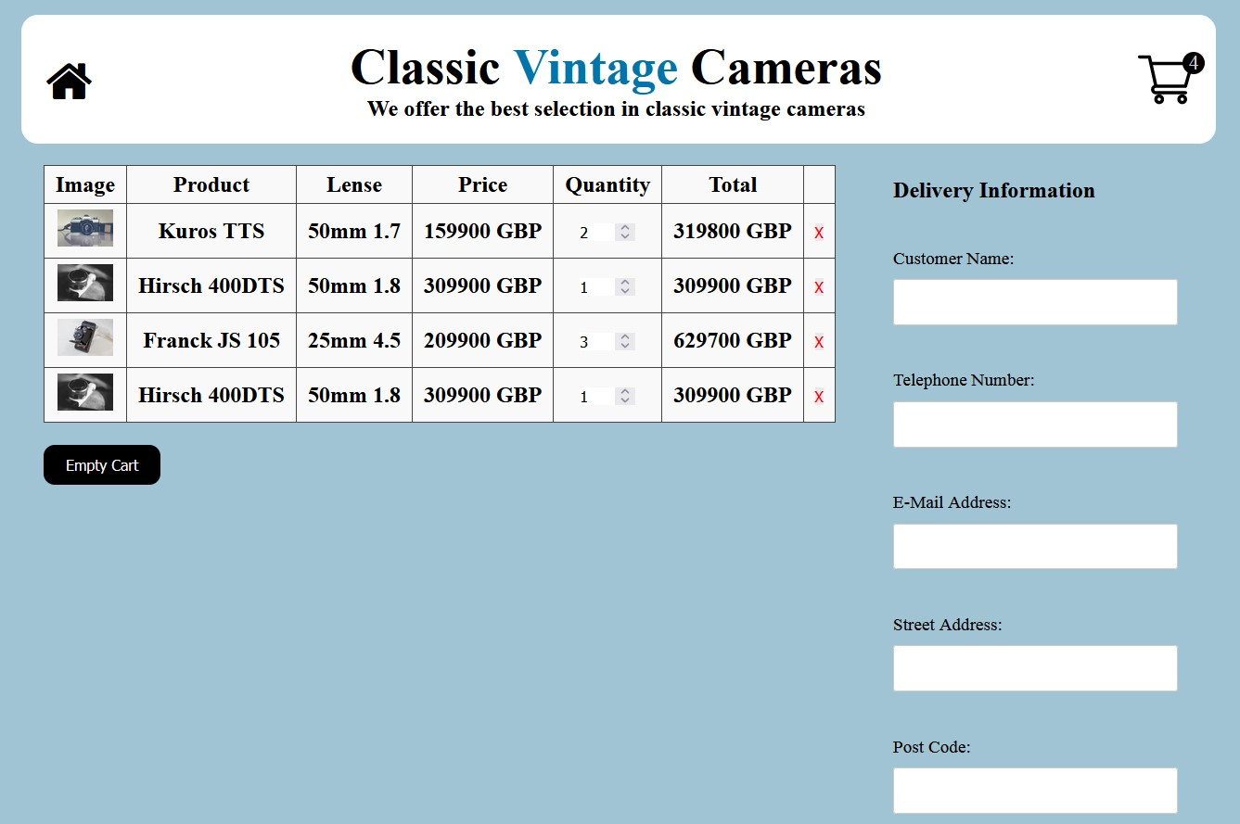

4. A user can view order confirmation on Order Received page

* + - User can see submitted Order ID

